|  |  |
| --- | --- |
| Address: | South Sinai, Sharm El Sheikh, Nabq Bay. |
| Reservation: | Tamra Beach Resort. |
| Category: | 4 star Hotel, The Hotel has All Inclusive" concept. |
| Chain: | Egyptian Vacation Club |
| Location: | Located at the southern tip of the Sinai peninsula, in Nabq, overlooking the straits of Tiran. 20 KM from Neama Bay. |
|
| Rooms: | Total: 244 |
| Standard Rooms |
| Family Rooms |
| Suites |
|  |
| Features: AC, telephone (IIDD) , mini-Bar, satellite TV, safe, hairdryer, bathroom and shower, balcony, |
|
| Rooms View: | Sea View / Pool View/ Garden View. |
| Conference Room: | One for 250 Person and One for 500 Person. |
| Lobby Lounges: | Lounge and Club House. |
| Restaurants: | Main Buffet Restaurant for ( Breakfast, Lunch & Dinner), Fish Restaurant at Dinner –(chargeable) |
| Bars: | Pool Bar, Beach Bar and 2 pool bars. |
| Beach: | Private sea beach. Chaise longue, umbrellas and towels are free of charge |
| Swimming pools: | 8 pools including 1 for children and 1 indoor (Chargeable). 02 Heated Swimming Pools during the winter. Umbrellas and towels are free of charge. |
| Laundry: | Available at the hotel (chargeable) |
| Shops: | Souvenirs shop, Silver, Local Handicraft, Bazaar, Mobile Shop and Super Market. |
| Sports and others: | Sauna & Steam Bath (chargeable)Aerobics , Volleyball , Darts, Fitness room , Tennis Table , Tennis court & Amphitheater |
| Diving Center (chargeable): Diving, Snorkeling, Sea Trips and various water sports activities |
| Massage :Four treatment rooms offering different style of massage (chargeable) |
| Beauty Salon (chargeable), ATM, Free On-Site Parking, Doctor (Chargeable), Shuttle bus to Neama Bay and Old Market With Previous reservation. Club House With TV room available. |
| Transportation: | Limousine Service : 24 hours upon request (Chargeable) |
| Animation and Kids activities : | Available. |
| Pets: | Not allowed |
| Credit Cards: | Visa and MasterCard |
| website | [www.evcresorts.com](http://www.evcresorts.com) |
| Wi-Fi: | 250 KB. Free of charge at the Lobby and 2 MB with 3 $ for 2 weeks in public areas. |

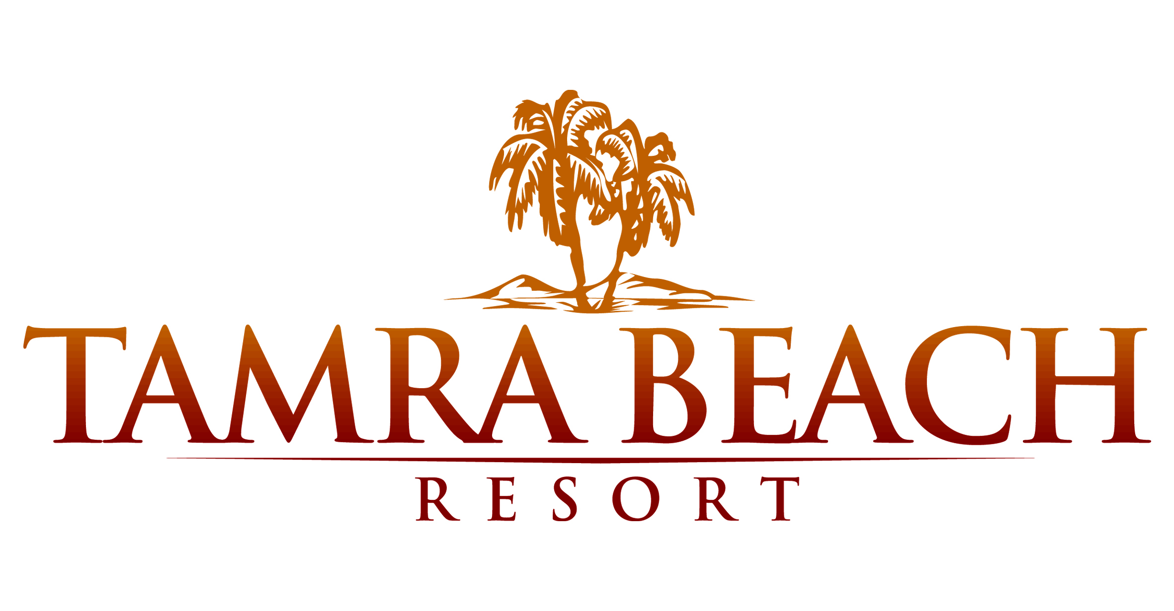

Fact Sheet