Badawia Sharm Resort
(Sharm El Sheikh)
EGYPT
Fact Sheet
3***
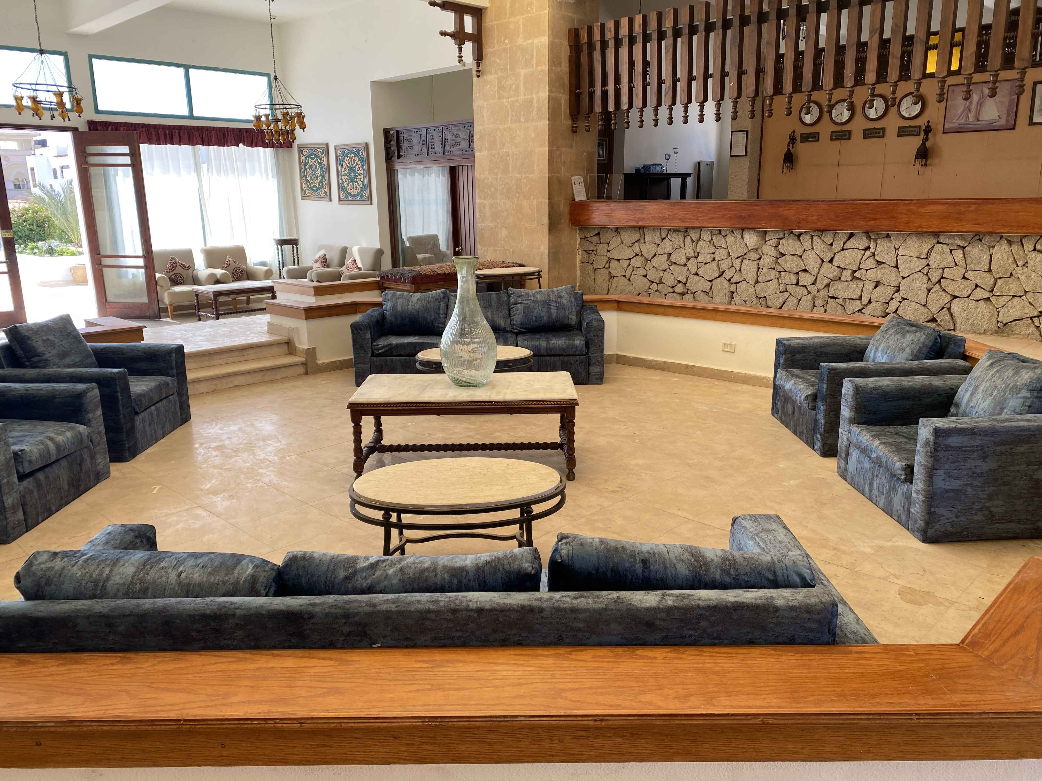
Location:

At Om el Sid hill, at the point of Sinai Peninsula here you can stay in a
Comfortable room overlooking the garden or swimming pool … its setting
Between the desert and red sea makes it an ideal spot for diving among
Some of most beautiful coral in the world or for exploring the magnification
Landscapes of Sinai desert.

Address

Hadaba Om EL Seed P.O. Box 252 Sharm El Sheikh South Sinai Egypt
Tel. (+20) 1016640021
Email: Chairman@badawiasharm.com
27 km form sharm el sheikh international airport
3 km form city's bus station and old market

Rooms:

80 rooms with view of swimming pool or garden (2 Suite -78 standard room)

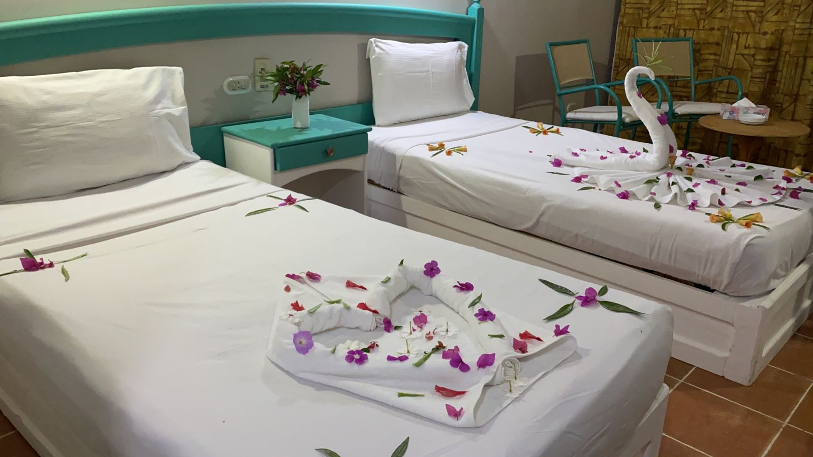

All rooms have air-conditioning and heating, phone, satellite TV , minibar and
Bath room with shower
Some rooms are communicating

Chldern:

Child's cot available (up to 4 years old)
And high chairs are available in the restaurant
Kids corner in the garden area
Children's pool

Restaurant & Bars :

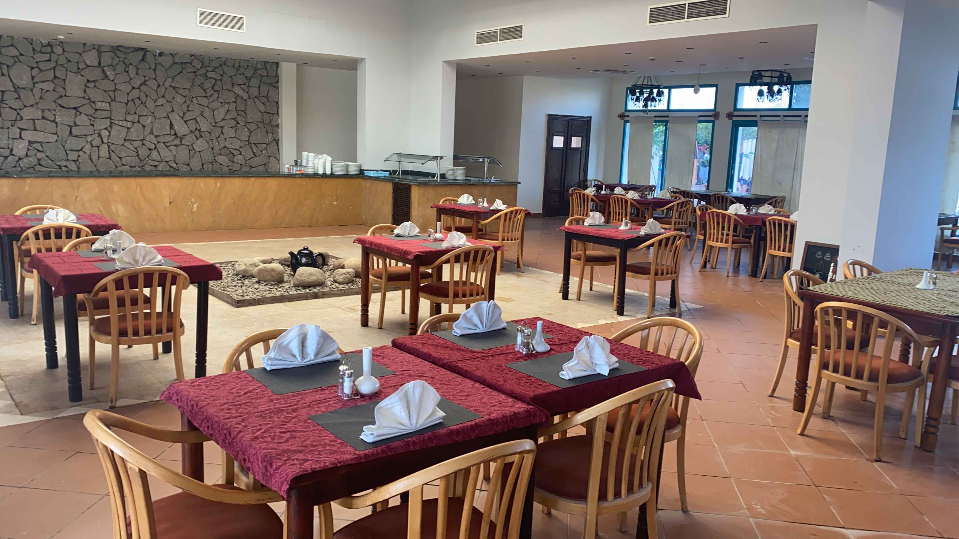

International cuisine (lunch a la carte, theme dinner), snake-par
The par is available for snake and drinks
Entertainment:
* 2 outdoor freshwater swimming pools
* Billiards" and table tennis
* Health club (massage )
Jasmine pub:

Beauty Salon

For your leisure:

2 outdoor freshwater swimming pools
Billiards" and table tennis and massage center

Sports
Diving center- valley ball – water ball
Available Serveces :

Private car park, baggage room, safe deposit box, Credit/debit cards accepted; visa
master card, American express cash machine of exchanging money,

Shuttle Bus Facilities :

Free of charge from the hotel to the beach and back.

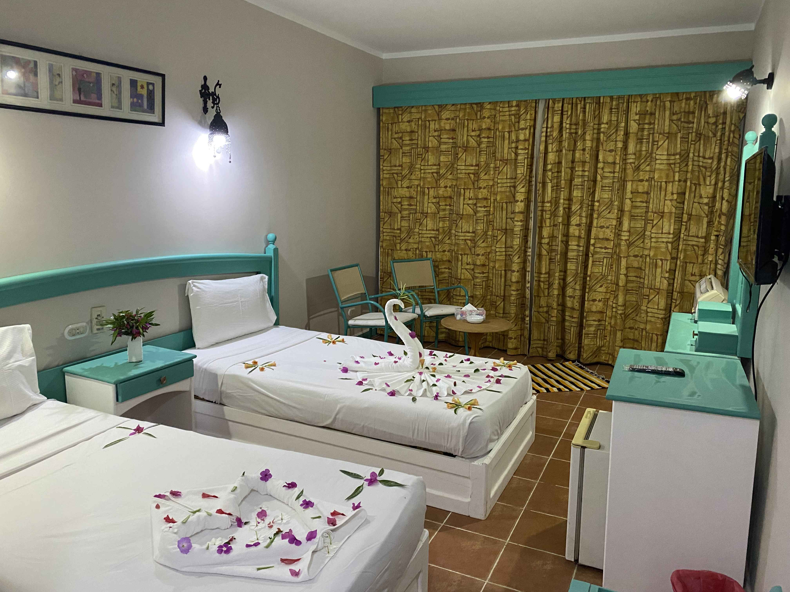

We wish for our client's wonderful holiday in our hotel

