Hotel Fact Sheet – Shams Safaga Resort

Sales & Reservation Office
37 Baghdad st., Heliopolis,
Cairo, Egypt
Tel: +202 24170046 Fax: +202 24170158
Email: info@shamshotels.com

Hotel Shams Safaga Resort
Hurghada - Safaga Road 8Km - Safaga - Hurghada
Tel: (+2) (065) 3260044/48
Fax: (+2) (065) 3260043
Email: shamssafaga@shamshotels.com

www.shamshotels.com

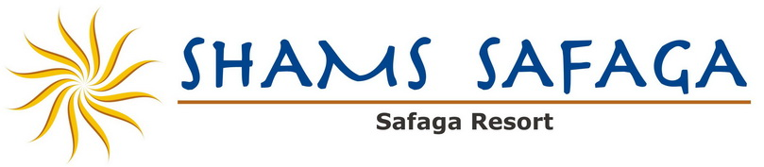
Where warmth is more than just sunshine !

SHAMS means “SUN” in Arabic, we are proud to invite you to experience the warmth of the sun and the warmth of our hospitality. WE offer fine service, pristine beaches, and a wide selection of activities and amenities ALL FOR A GREAT VALUE.

Shams Safaga Resort in a few words is a beautiful long sandy beach, crystal clear waters, a wide selection of water activities, (scuba diving, snorkeling, wind and kite surfing), bungalows located directly at the beach or in the vast green gardens, and friendly service and atmosphere. The resort is ideal for families and relaxation far away from everyday life.

Safaga
Safaga has breathtaking beaches, a unique location between, desert, Sea, and the 2000 meter high mountain range; it is an ideal setting that is not followed by mass tourism. The ancient port city was used by the pharaohs for trade and the exploration of the Red Sea. In the 19th Century Safaga’s strategic importance was reinforced by the discovery of phosphate mines in the mountains.

DISTANCES
From Hurghada Airport 45 km
From Hurghada City 50 km
From Safaga City 8 km
From Luxor 210 km
From Cairo 550 km

LEISURES, FACILITIES & ACTIVITIES
The long, natural sand beach invites for relaxing as well as for a various sport activities. The animation and sports program with its team and evening shows provide fun & entertainment for everyone.

- Kids Club, kids pool and playground
- Shams Spa Center
- Tennis / Table tennis
- Billiard
- Minigolf
- Shams Diving Center with certified instructors
- Aqua Center
- Windsurfing (Club Mistral)
- Kitesurfing (Sky Riders)

ACCOMMONDATION
The Resort comprises 340 rooms in one main building or bungalows with different categories, fantastic sea / garden or view into the mountains, balcony or terrace. Our beautiful bungalows are located direct at the beach or in middle of the garden with its palm trees.

- Standard Rooms
- Family rooms (with connected door)
- Bungalow rooms

SERVICE & AMENITIES
The hotel and a 24 hours front desk with friendly, multilingual staff offer the following services:

- Internet Corner
- Bank
- 24 hour on call doctor
- Bus shuttle (Safaga City 5 km, Hurghda City 50 km)
- Laundry
- Gift / souvenir shops

DINING, RESTAURANT & BARS
All Inclusive, tasteful meals and a selection of beverages served in 3 different restaurants (1 non smoking restaurant), 4 bars and a nice area with the flair of 1001 nights, our “Dawar El Omda Oriental Café.

- The Garden Restaurant
- The Coffee Shop
- Palm Beach Snack Bar
- The Dolphin Restaurant

If you need further information, please contact directly the hotel shamssafaga@shamshotels.com

