All Inclusive – Shams Alam Beach Resort

Sales & Reservation Office
37 Baghdad st., Heliopolis,
Cairo, Egypt
Tel: +202 24170046 Fax: +202 24170158
Email: info@shamshotels.com

Hotel Shams Alam Resort
South Marsa Alam Road 45km, Red Sea, Egypt
Tel: (+2) 01222444931/932
Fax: (+2) 01222401425
Email: alam@shamshotels.com

www.shamshotels.com

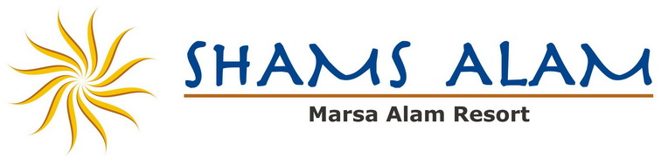
Where warmth is more than just sunshine!

Shams Alam Beach Resort & Beach
All-inclusive plan
Includes:
- Welcome drink.
- Full board.
- Breakfast from 07.00hrs till 10.00hrs in the main restaurant.
- Dinner from 19.00hrs till 22.00hrs in the main restaurant.
- Lunch from 13.00hrs till 15.00hrs.
- Teatime with cakes & snacks from 16.00hrs till 17.00hrs.
- Ice cream from 12.00hrs till 18.00hrs.
- Glasses of soft drinks and mineral water
- Glasses of local beer, wine, and all kind of local alcoholics in the outlets as of 10.00 o’clock
till 24.00 o’clock. After 24.00 o’clock it will be served against charge.
- All taxes & service are inclusive.
- All sport facilities available in the hotel as beach volleyball, beach football, Gym, tennis table,

All inclusive not includes the following:

- Fresh juices.
- Massage.
- Sauna.
- Horse riding.
- Billiard.
- Mini bar in the room
- All motorized beach sport i.e.
(Diving, fishing trip, glass bottom boat)

