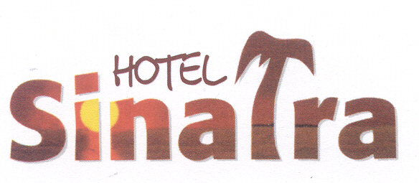

**HOTEL SINATRA ALL INCLUSIVE CONCEPT**

**BREAKFAST :07:00 – 09:30 OPEN BUFFET**

**LATEST BREAKFAST :09:30 – 10:00 OPEN BUFFET**

**LUNCH : 12:30 – 14:00 OPEN BUFFET**

**TEA TIME : 17:00 – 17:30 COFFEE, TEA AND CUPCAKES ETC.**

**DINNER : 19:30 – 21:15 OPEN BUFFET**

**POOL BAR : 11:00 – 23:00 ALCOHOL (ONLY BEER AND WINE) NON-ALCOHOLIC LOCAL DRINKS (SELF SERVICE)**

**HAMMAM : 08:00 – 20:00**

**EXTRAS : SAUNA & MASSAGE, BILLIARDS, HOOKAH, SAFE, WATER SPORTS, TELEPHONE, FRESH SQUEEZED FRUIT JUICES, ICE CREAM, IMPORT DRINKS, DOCTOR, LAUNDRY SERVICE, DRY CLEANING.**

**WE DO NOT HAVE FOOD AND BEVERAGE SERVICE ON THE BEACH!**