# All inclusive Adults only hotel (16+)

Enjoy a fun and relaxing time in this cosy 3 *** All inclusive (16+ years old) adults-only hotel with interiors inspired by Nordic design.

Here you can enjoy a relaxing and cozy holiday in a friendly environment. This boutique-style hotel has 47 rooms and is located next to the Golden Sands Nature Reserve. An attractive offer of tranquillity, green surroundings and access to the sandy beach reserved for all guests, combined with a welcoming and personal atmosphere, place the hotel at the top of the list for high guest satisfaction.

# Highlights and new services

**NEW**: **BEACH SERVICES INCLUDED**: 2 deckchairs and an umbrella per room, 2 times a day shuttle service to the beach area reserved for Foresta guests.

* Adults only (16+ years)
* Late breakfast until noon
* Free bicycle hire (up to 4 hours per day; reservation required)

**NEW: E-bikes available against deposit**

* Tea & Coffee facilities free of charge in all rooms
* Theme BBQ evenings (July-August)
* Parking is free of charge for guests of the hotel.

# General information

* All Inclusive basis
* 3-storey building
* 800 m from the beach
* 15 km from Varna
* 30 km from Varna Airport
* 800 m from the center of the resort
* 800 m from the shopping center
* 20 m from a public bus station
* Languages spoken: Bulgarian, English, German, French, Russian
* 24-hours reception & 24 hours security
* Main restaurant, Snack menu, Sweets in the afternoon
* Lobby bar and Pool bar offering variety of local alcoholic and non-alcoholic beverages
* Parking - limited and free of charge for hotel guests
* GRIFID Souvenir Shop
* Free Wi-Fi connection in hotel lobby area and in the rooms
* Taxi & Rent-a-car services
* Laundry and ironing service - at a charge
* Doctor

# Accommodation

* Check-in time - from 15:00h - starts with afternoon snack menu
* Check-out time - until 11:00h - ends with continental breakfast
* 47 hotel rooms with pool view
* All rooms are with bathroom shower
* Separated wash basin from the bathroom
* Hairdryer
* International dialing phone
* Central air conditioning system
* Satellite TV
* Free Wi-Fi connection
* In-room safe against extra charge
* Mini bar - free of charge, daily restocked /water, soft drinks, beer/
* All rooms are with laminated floor
* Balcony
* Tea & Coffee facilities free of charge in all rooms
* Pillow menu

*Early check-in and late check-out depend on the availability of the hotel and are subject to additional payment.*

# Restaurants

Part of All Inclusive basis

**MAIN RESTAURANT**

Breakfast 07:30 - 10:00 buffet

Continental breakfast 10:00 - 12:00 table service

Lunch 12:30 - 14:00 buffet

Dinner 18:00 - 21:30 buffet

* Buffet breakfast, lunch and dinner
* Varied culinary delights
* Beverage buffet with mineral water, soft drinks, draft beer and country wine, coffee and tea
* Culinary theme buffets - 2 times per week
* Ice cream station 12:30 - 18:00
* No smoking inside

**SNACK**

Afternoon Snack 15:00 - 17:00

# Bars

Bars - part of All Inclusive basis  
  
**LOBBY BAR**

10:00 - 23:00

Coffee, tea, cookies 15:00 - 17:00

* Smoking is not allowed
* All inclusive offer features mineral water, local alcoholic beverages, non-alcoholic beverages and refreshing cocktails, coffee and tea, draft beer and country wine
* Bar service

**POOL BAR**Drinks 10:00 - 18:00 (pool operating time)

* All inclusive offer features mineral water, non-alcoholic beverages and draft beer
* Self-service

# Swimming pools and Wellness

**OUTDOOR POOL**

09:00 - 18:00

* Sunny lounge terrace by the pool
* Complimentary sun lounges, parasols and towels
* Life guard service provided

# beach services included

* One parasol and two sun beds per room on the beach upon availability (only for full paying customers)!
* 2 times per day shuttle service to the beach (one in the morning and one in the afternoon)

# Wellness and Relax

**(AT GRIFID HOTEL ARABELLA)**

*\*All treatments in Wellness center and in the Beauty salon procedures are additionally charged.*09:00 - 18:00

* Hammam with steam bath, sauna, hydro massage bath
* Relax zone
* Boutique - massage oils, fragrances and other body products
* Hairdresser, manicure and pedicure
* Massage rooms; facial and body treatments

# SPORT & ANIMATION Activities

* Evening entertainment show program once per week
* Table tennis, darts - free of charge
* Bicycle hire *up to 4 hours a day - free of charge
* Theme BBQ evenings (July and August)

# ROOMS

**Double room with pool view:** 29 m2. 2+0, 3+0.

# EXTRA Paid Services

* In-room safety box
* Rent a car
* Spa treatments in wellness center of GRIFID Arabella
* Services in beauty salon of GRIFID Arabella
* Bicycle hire (after the 4th hour a day)
* Transfer from and to Varna airport

# Miscellaneous

* Pets are not allowed
* Hotel reserves the right to change opening hours of the outlets, if necessary
* Under Bulgarian legislation it is not allowed to smoke in the hotel lobby, restaurant, bars and rooms (indoors)
* Sun bed reservation is not accepted. Any unattended towels are removed from the pool staff
* Food and beverages cannot be taken out of the restaurants due to Public and HACCP regulations

# Contacts

Tel.: +359 52 351 052 (Hotel Reception)  
Tel.: +359 52 394 972 (Marketing department)  
Fax: +359 52 351 055  
E-mail: [reservations@grifidhotels.com](mailto:reservations@grifidhotels.com)  
  
**WEBSITE**   
[www.grifidhotels.com](http://www.grifidhotels.com)

**PHOTOS AVAILABLE AT**  
<https://grifidforesta.pixieset.com/grifidhotelforesta/>

***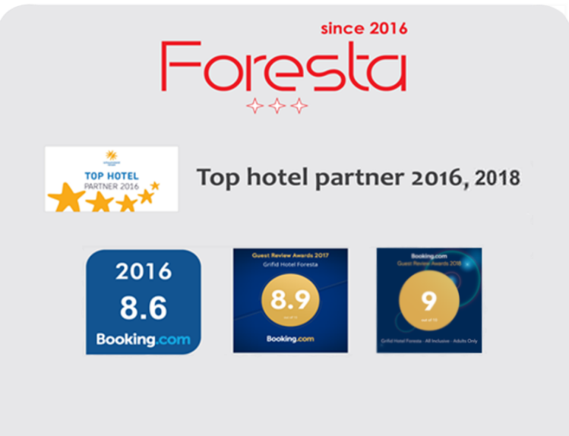*AWARDS**