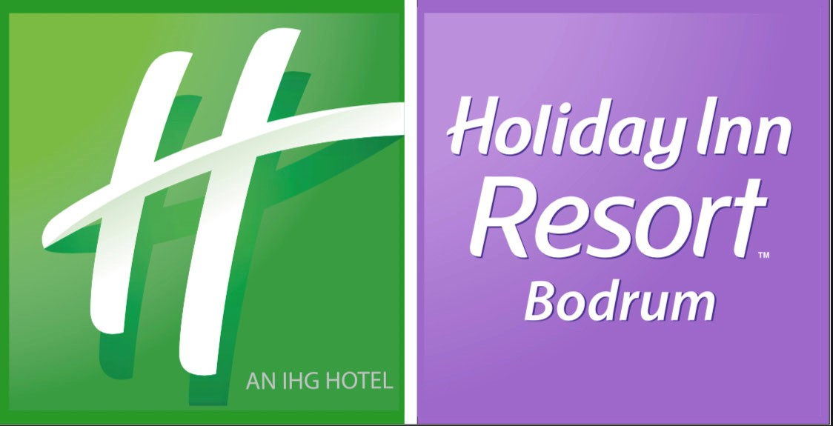

**LOCATION**

Located in the heart of Bodrum, where the breathtaking beauty of nature meets turquoise waters, **Holiday Inn Resort Bodrum**, invites you to a unique happiness with its eye-catching architecture and warm atmosphere. Our hotel has a magnificent location in the center of Bodrum, built on an area of ​​57.000 square meters, with a view of Kos island and Bodrum castle. **Our guests can reach till to the beach with elevators.**

Eskicesme, Haremtan Sk. No:1, 48400 Bodrum/Mugla

Location: Bardakci Bay

Distance to the Sea: 0 m

Distance to Bodrum Airport: 38 km

Distance to Bodrum City Center: 2 km

Distance to Bodrum Marina: 1.2 km

Distance to Gumbet Bar Street: 2.6 km

**ROOMS**

Our hotel has 2 types of rooms.

\***Hotel Rooms (Main Building):** 82 units. It is in the main building, It consists of a single room that can accommodate 2+1 people. The floor is ceramic. Bathrooms have showers. They are rooms with one large or two separate beds.

**\*Club Rooms:** 184 rooms. Independent from the main building, It consists of a single room that can accommodate 2 people. The floor is ceramic coated. Bathrooms are in the form of shower cabins. They are rooms with one large or two separate beds.

**CONCEPT**

Ultra All Inclusive Concept Features

• Breakfast (between 07:00 and 10:30)(Open Buffet)

• Lunch (between 12:30 and 14:30) (Open Buffet)

• Dinner (between 19:00 and 22:30)(Open Buffet)

• Midnight Buffet (between 00:00 and 01:00)

• Snack Service Hours (between 12:00 and 16:00)

• Taksim Kiosk (between 12:00 and 18:00) ( İstanbul street delicacies )

• Patisserie ( between 10:00 and 18:00 )

• Mother's corner (24 hours) (Blender, Microwave, Bottle sterilizing machine) (small box of milk)

• Service Bar (Main Restautant)(Soft drinks, Local & Import alcoholic drinks, tea and coffee options)

• Lobby Bar (24 Hours)(Soft drinks, Local & Import alcoholic drinks, tea and coffee options)

• Pool Bar (between 09:00 and 24:00) (Soft drinks, Local & Import alcoholic drinks, tea and coffee options)

• Beach Bar (between 10:00 and 18:00) ( Soft drinks, local alcoholic drinks )

• Lounge Bar (between 20:30 and 00:00) ) (Soft drinks, Local & Import alcoholic drinks, tea and coffee options)

• Minibar ( 2 beers, 2 cokes, 2 sodas, 2 juices and water ) ( refilled daily )

• Market ( Extra )

• Hookah ( Extra )

In the Ultra All Inclusive Concept; Breakfast, lunch and dinner are open buffet.Local & Import alcoholic drinks and non-alcoholic beverage service is free of charge within the brands determined by the facility. Our import beverages include vodka, gin, tequila and 12-year-old whiskeys. Lobby Bar is open 24 hours.

**A LA CARTE RESTAURANTS**

* Sea Food

Our A la Carte restaurant is free of charge one-time fort the stays 7 nights or over. Opening and closing hours of the food and beverage units are determined by the facility management according to the weather conditions and hotel occupancy.

**POOL & SEA**

Our facility is located by the sea. Our hotel has a private beach area which has blue flag for its cleanness. We make your holiday more enjoyable with 1 outdoor swimming pool and 1 children's pool.

* Sunbed
* Outdoor pool
* Kiddy pool
* Umbrella
* Private Beach
* Beach towel
* Platform Beach
* Pavillion ( extra )

**SPA & BEAUTY CENTER**

* Sauna
* Turkish Bath
* Massage ( extra )
* Fitness Center

**ACTIVITIES & ENTERTAINMENT**

Special Night Shows

Live Music

Sport Animation

Water Sports ( extra )

**Night Club** (It is a nightclub where live DJs and quality music combine with a magnificent view. Reinforcing the magic of the Aegean Sea and the Bodrum Castle view. Night Club is not included in all inclusive concept.)

**Wedding Hall**

Wedding – Invitation – Cocktail – Premiere parties ( not included in all inclusive concept )

Holiday Inn Resort Bodrum became the first hotel in Turkey and the 45th hotel in the world to serve under the Holiday Inn Resort brand by 2023. Breaking new ground in the world, Holiday Inn Resort Bodrum joined the IHG Hotels & Resort brand with its Ultra All Inclusive concept. All our guests staying at our hotel will have the privilege of making reservations with the points they earn from all their stays in the IHG Hotels & Resort group, which has 18 Hotel Brands, 6,164 Hotels and 911,627 rooms with the IHG One Reward Loyality service. We share the hotels within the brand with you.

