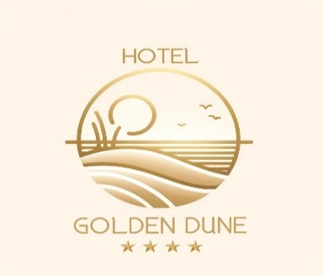

ALLINCLUSIVE PROGRAM 2026
HOTEL GOLDEN DUNE- SUNNY BEACH

Breakfast buffet 07.30 - 10.00

Lunch buffet 12.30 - 14.00

Cakes, ice cream buffet 16.00 - 17.00

Dinner buffet 18.30 - 20.30

All DRINKS

From 11.00 to 22.00 at the Restaurant Garden

From 11.00 to 18.00 at the Pool bar

Tea, coffee, milk, water, alcohol free drinks, juice - from dispenser

Locally spirits drinks- beer, wine, vodka, gin, mint , shnapps ,mastic, rom

Once a week - Italian dinner

Once a week - Bulgarian dinner

Bulgarian show program once a week - in July and August in Restaurant
- Kids club 4 - 12 years in July and August
- Animation for children and adults- 6 times per week / mini disco, aqua zumba, cocktail games, water polo, darts, ping pong, uno, entertainment/ - in Juli and August

Free of charge – gym, table tennis, parking, sun beds and umbrellas at the pool, wi-fi , baby cot, badminton, children chair in restaurant, card games, chess, kids club, children playground.

With Charge – doctor, massage, sauna, mini-bar, telephone, safe, bicycle.

BEACH AND POOL TOWELS ARE NOT PROVIDED

NO PETS ALLOWED
HEATED OUTDOOR POOL

